**Project 1 – VPC with Public- Private subnets**

**Steps and Snaps are following:**

**Step 1 – create a VPC  
  
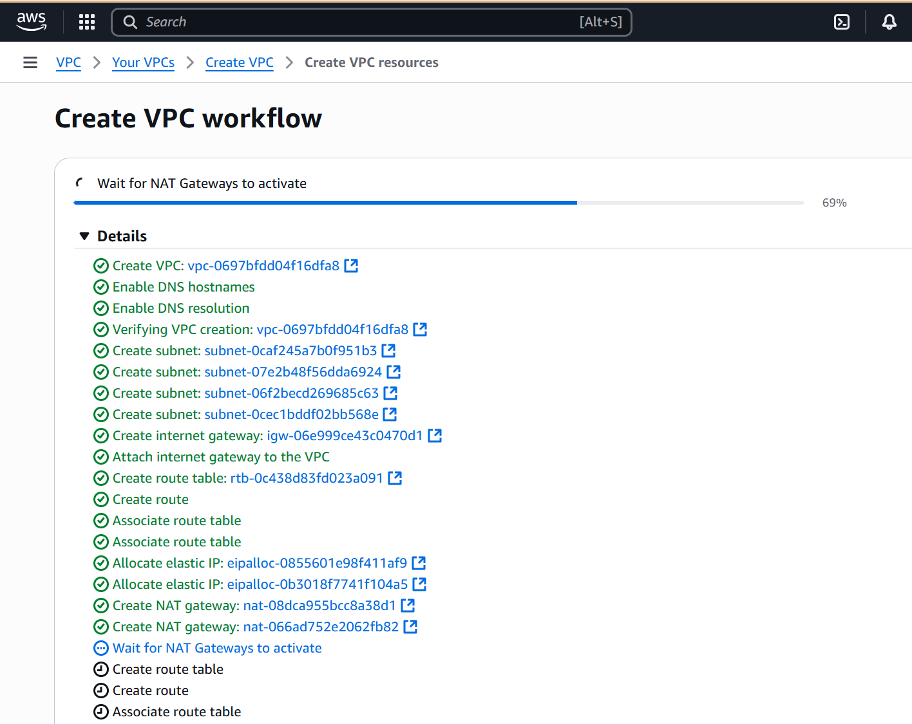  
  
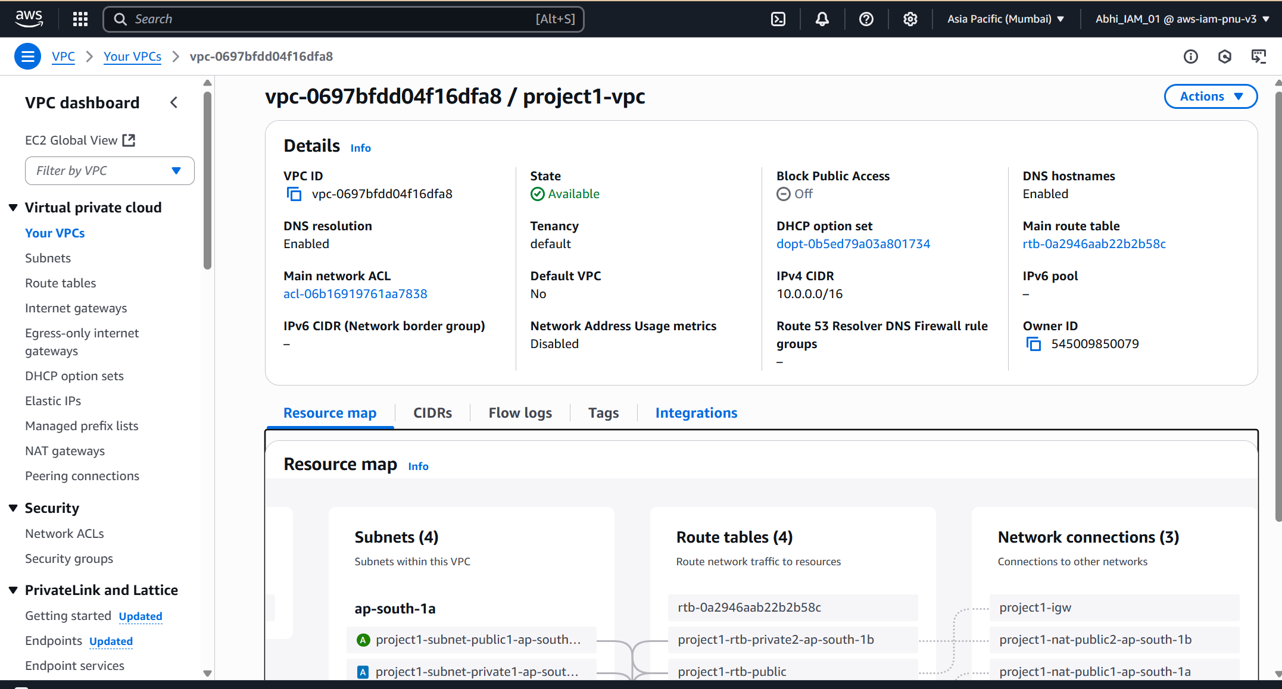**

**Step 2 -Create a ASG(auto scaling group )  
  
1. Create launch template:**

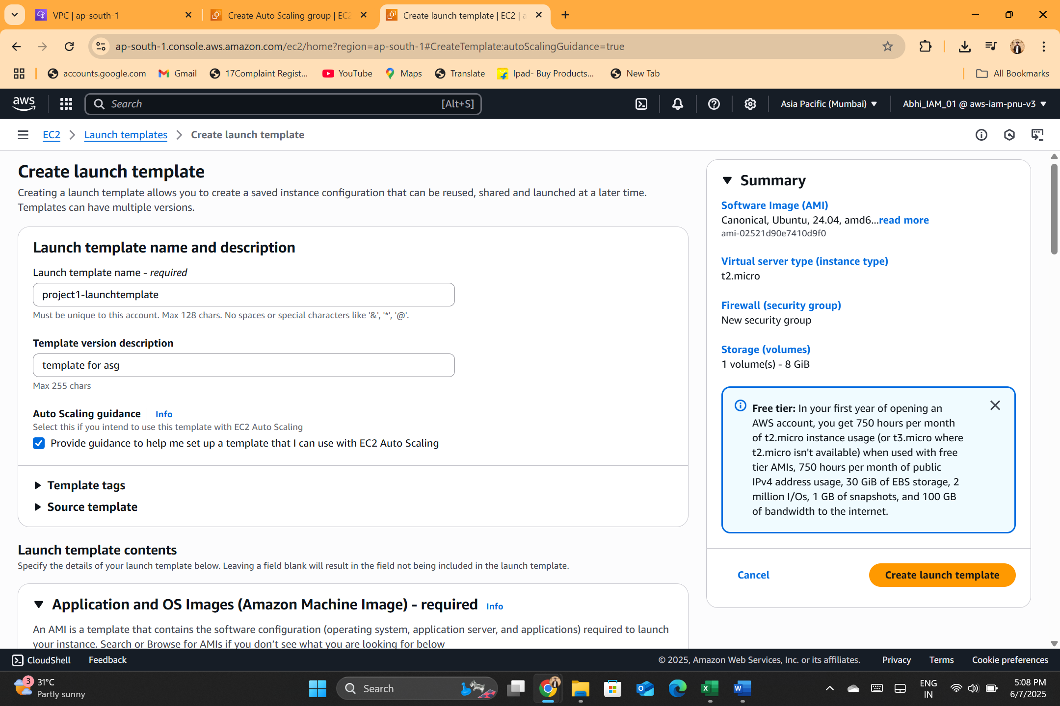

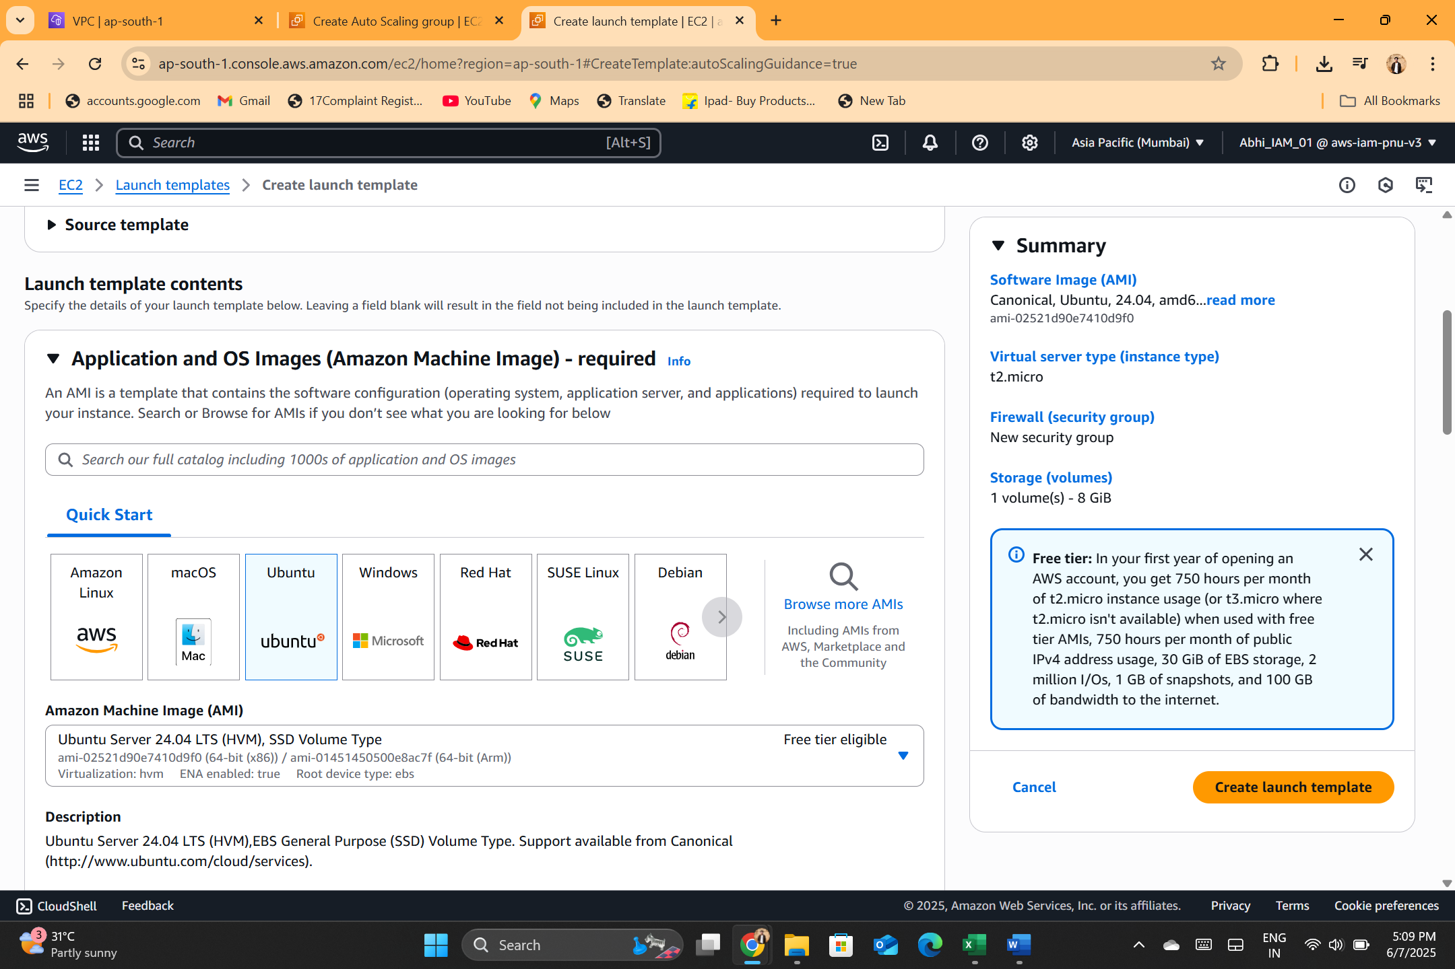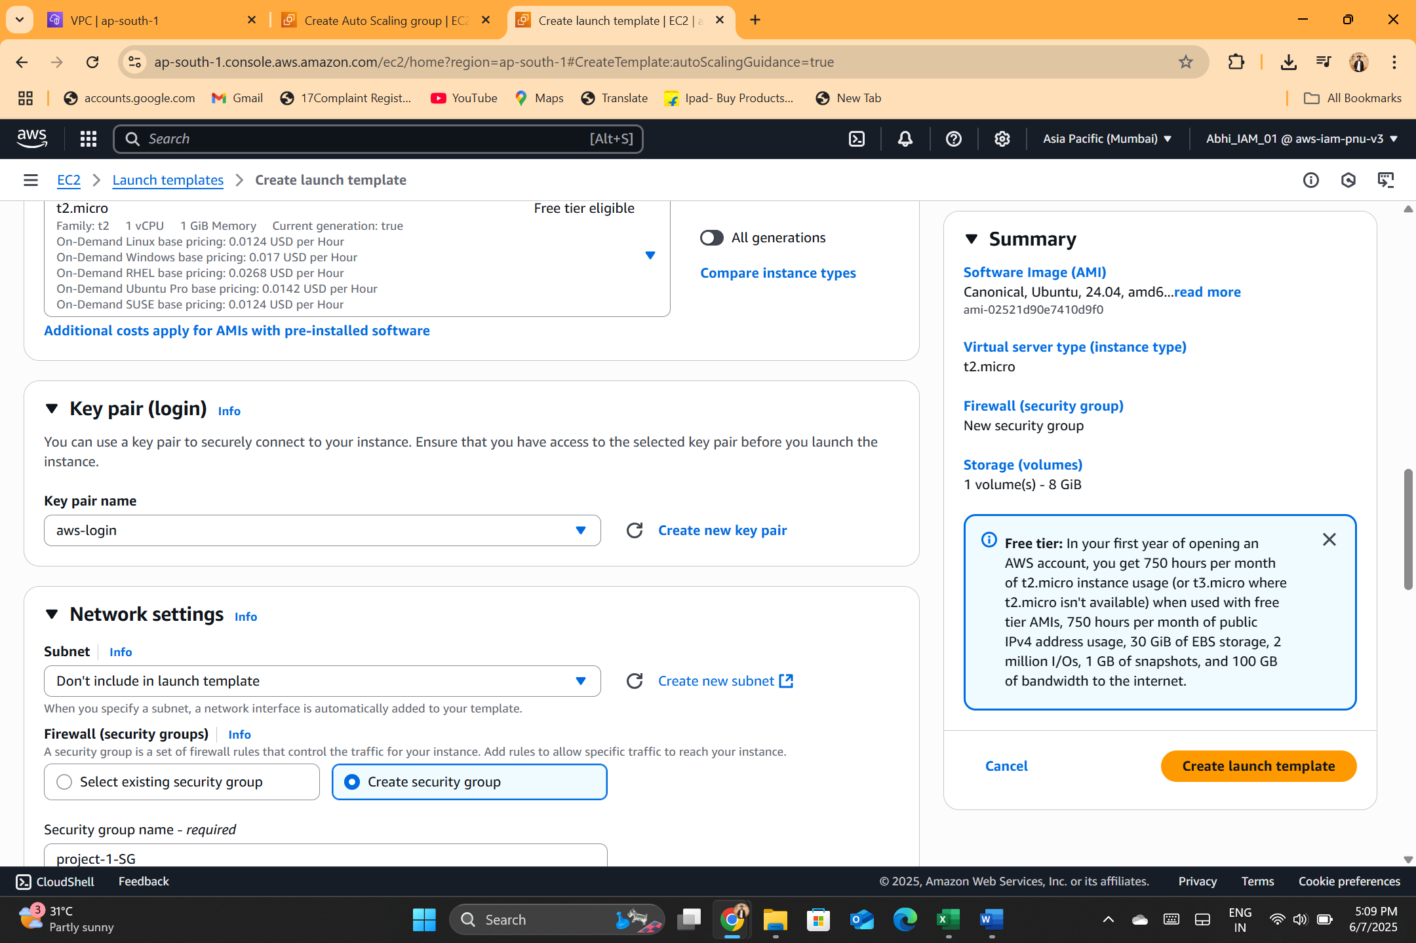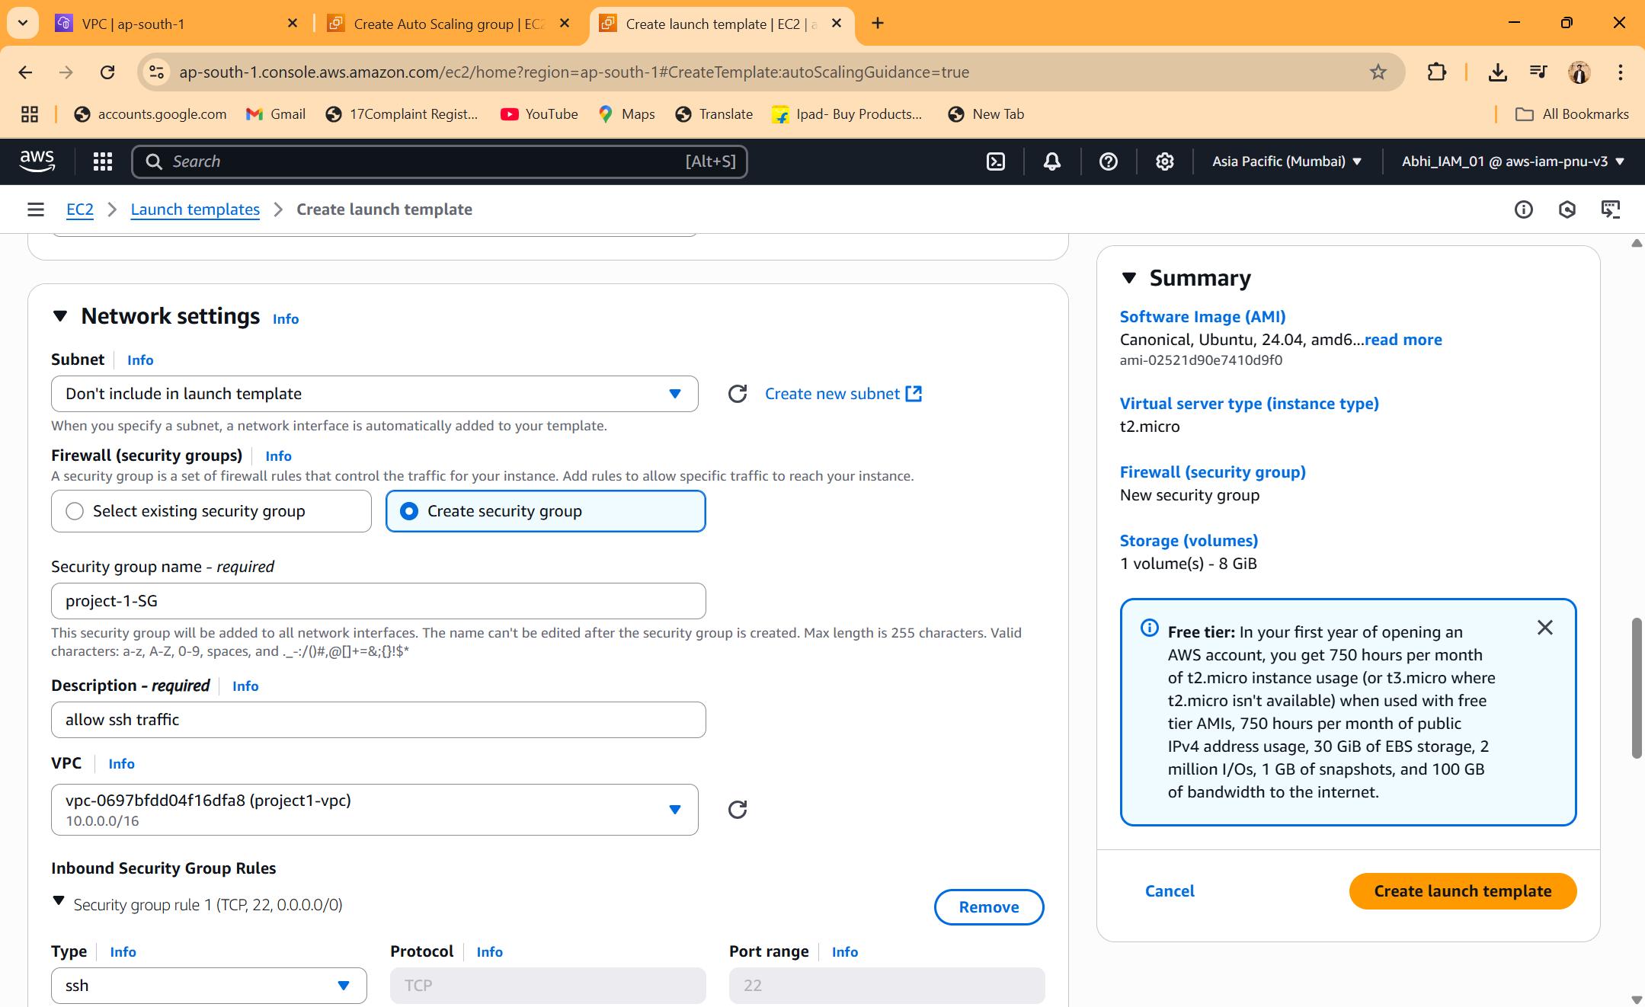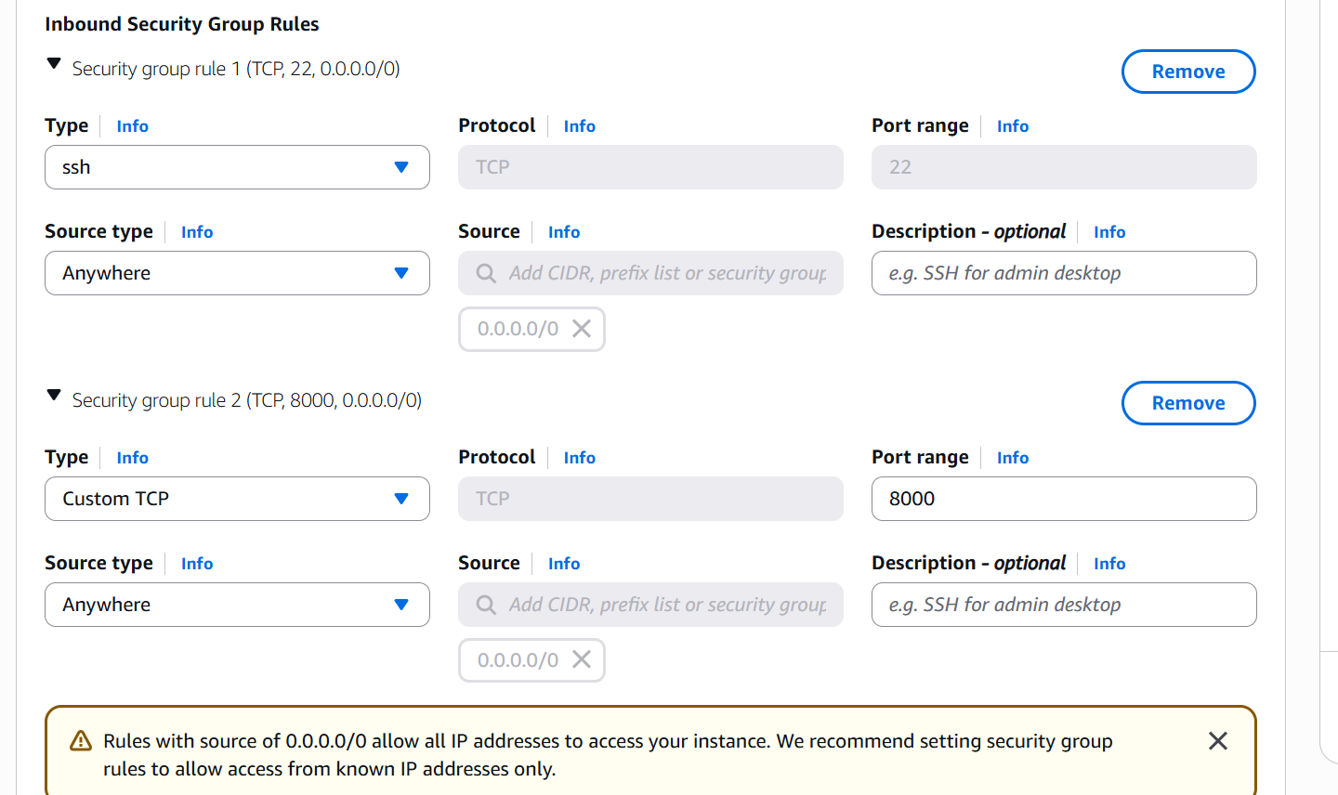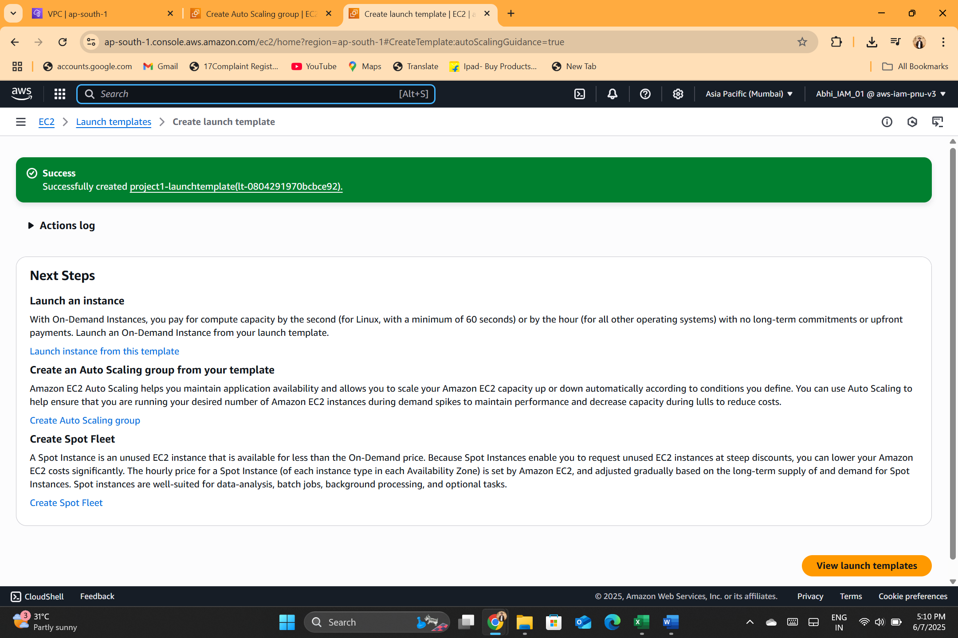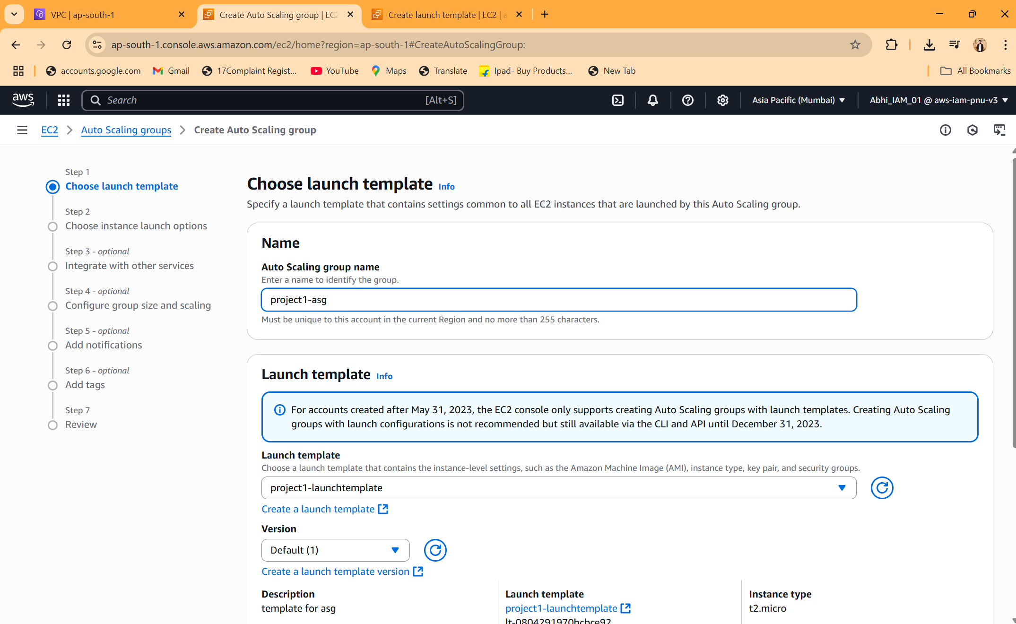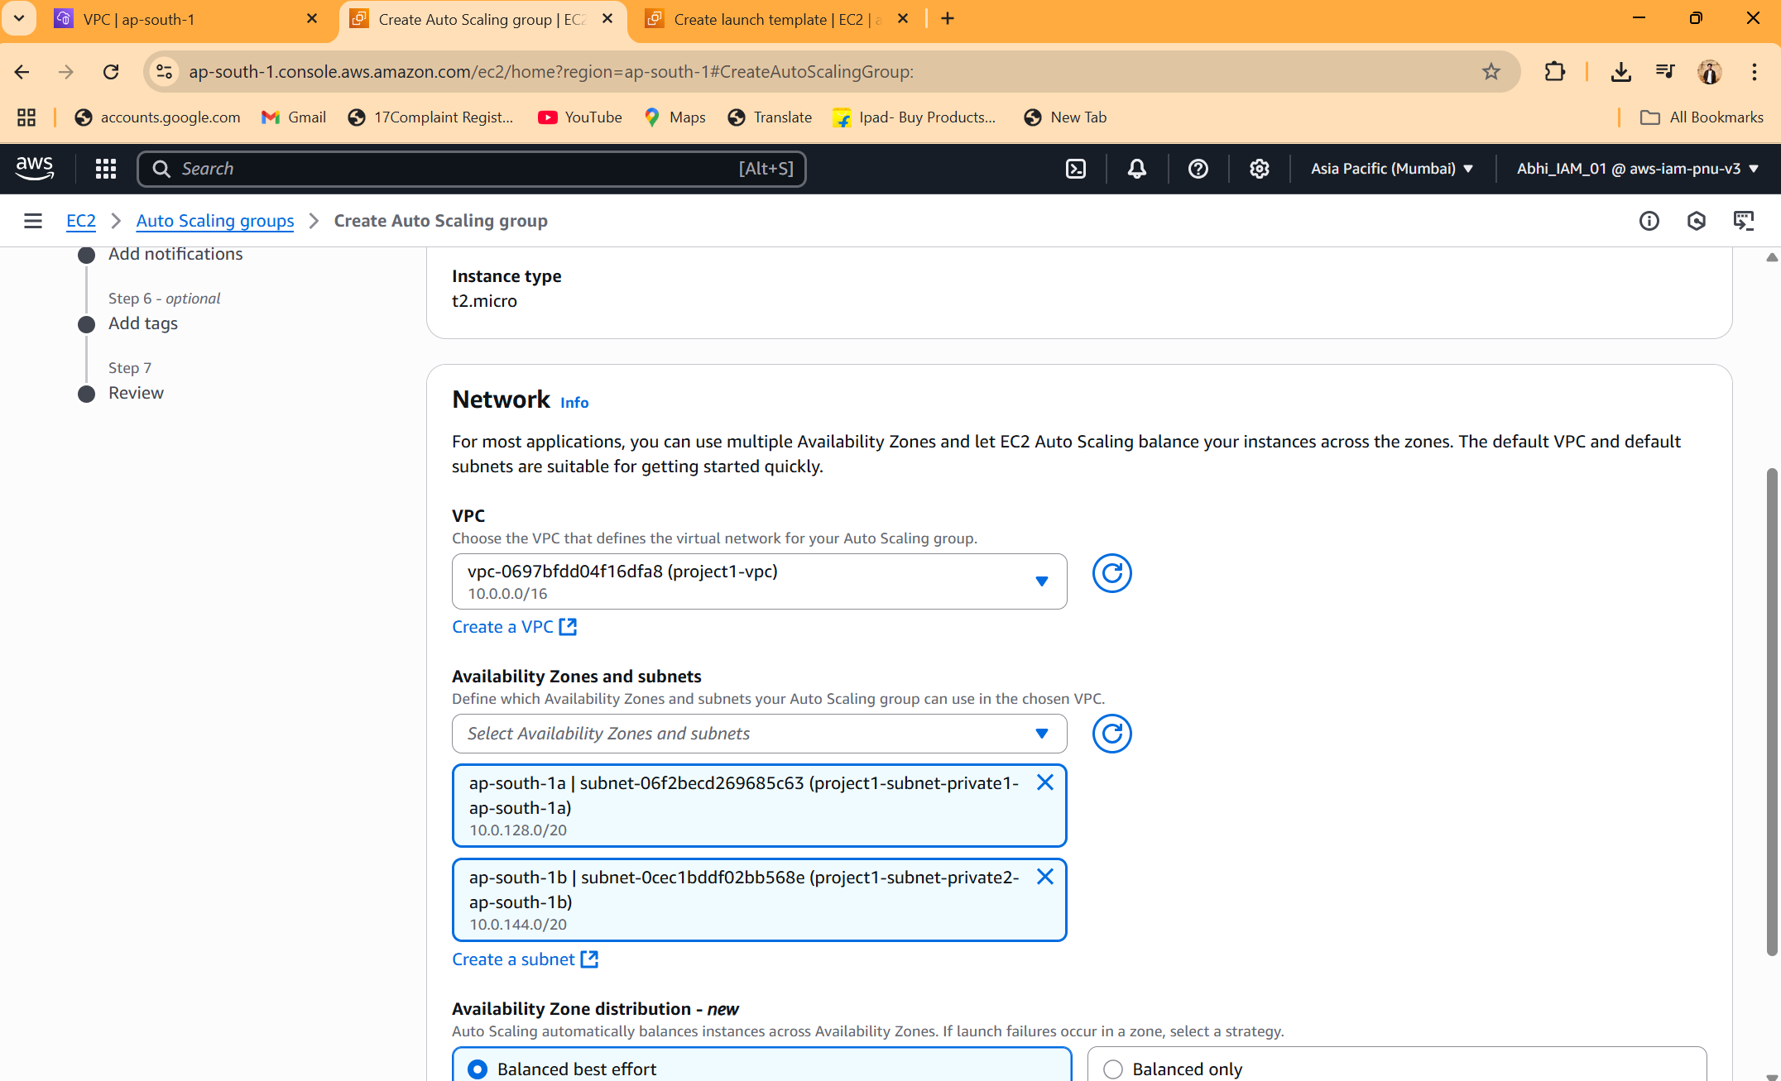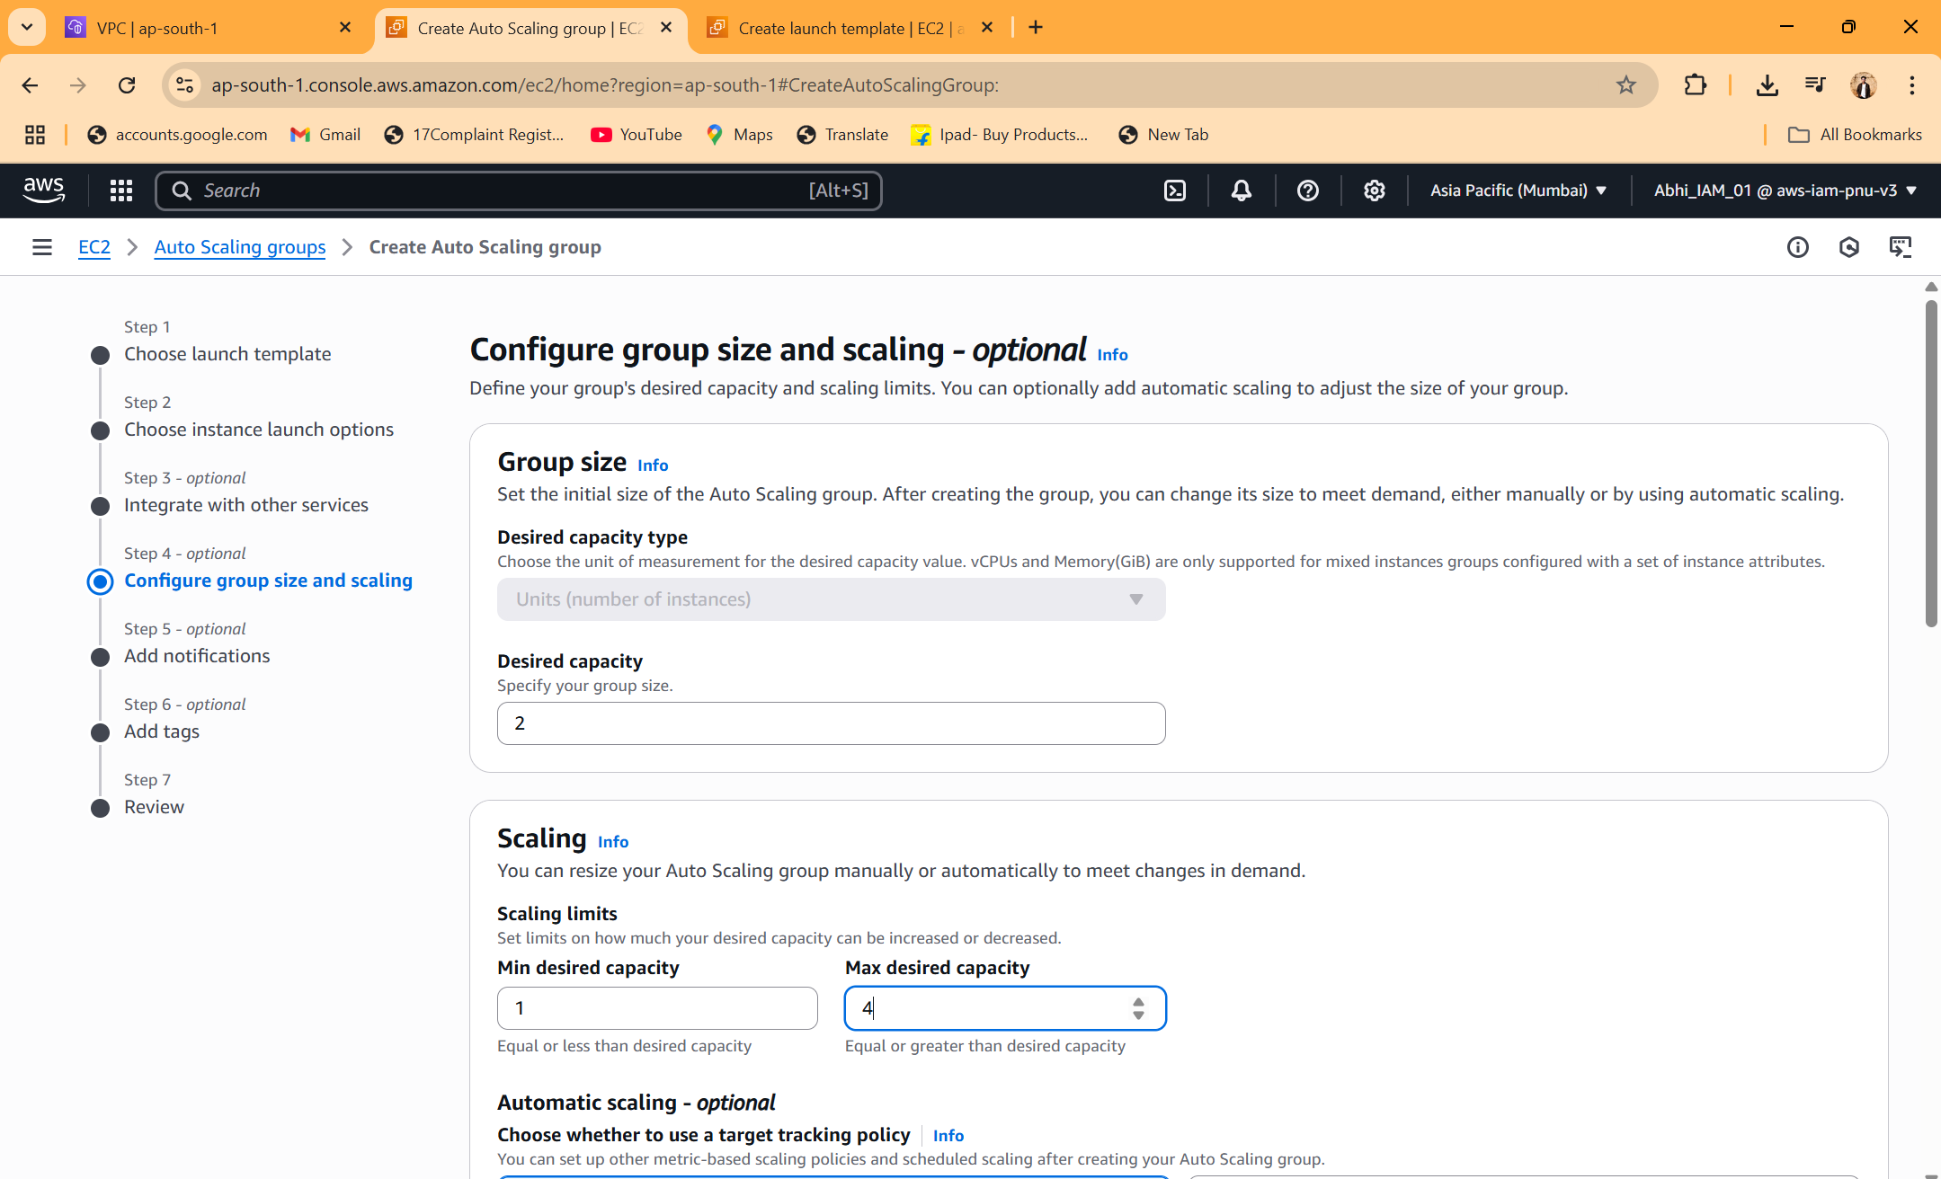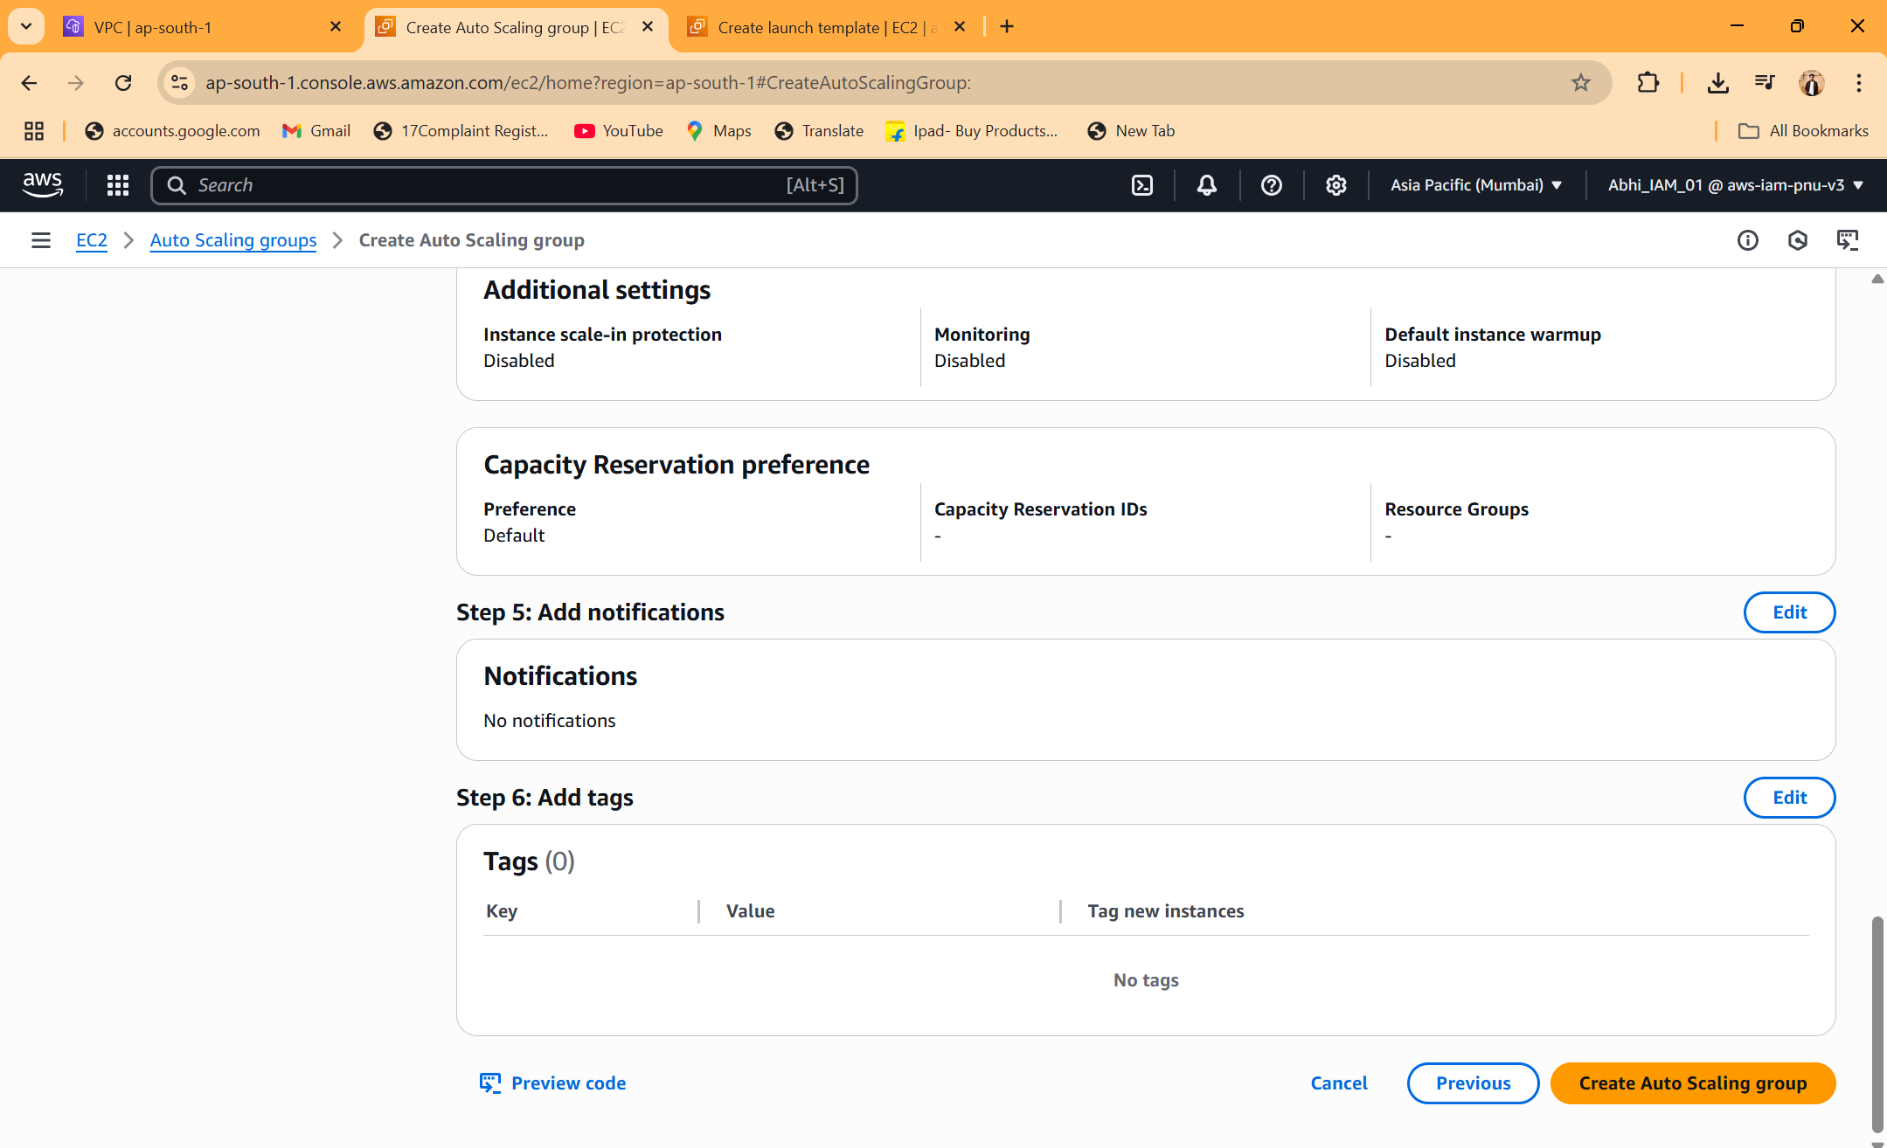

*After creating ASG check the instance are launched and they are in different availability zones

**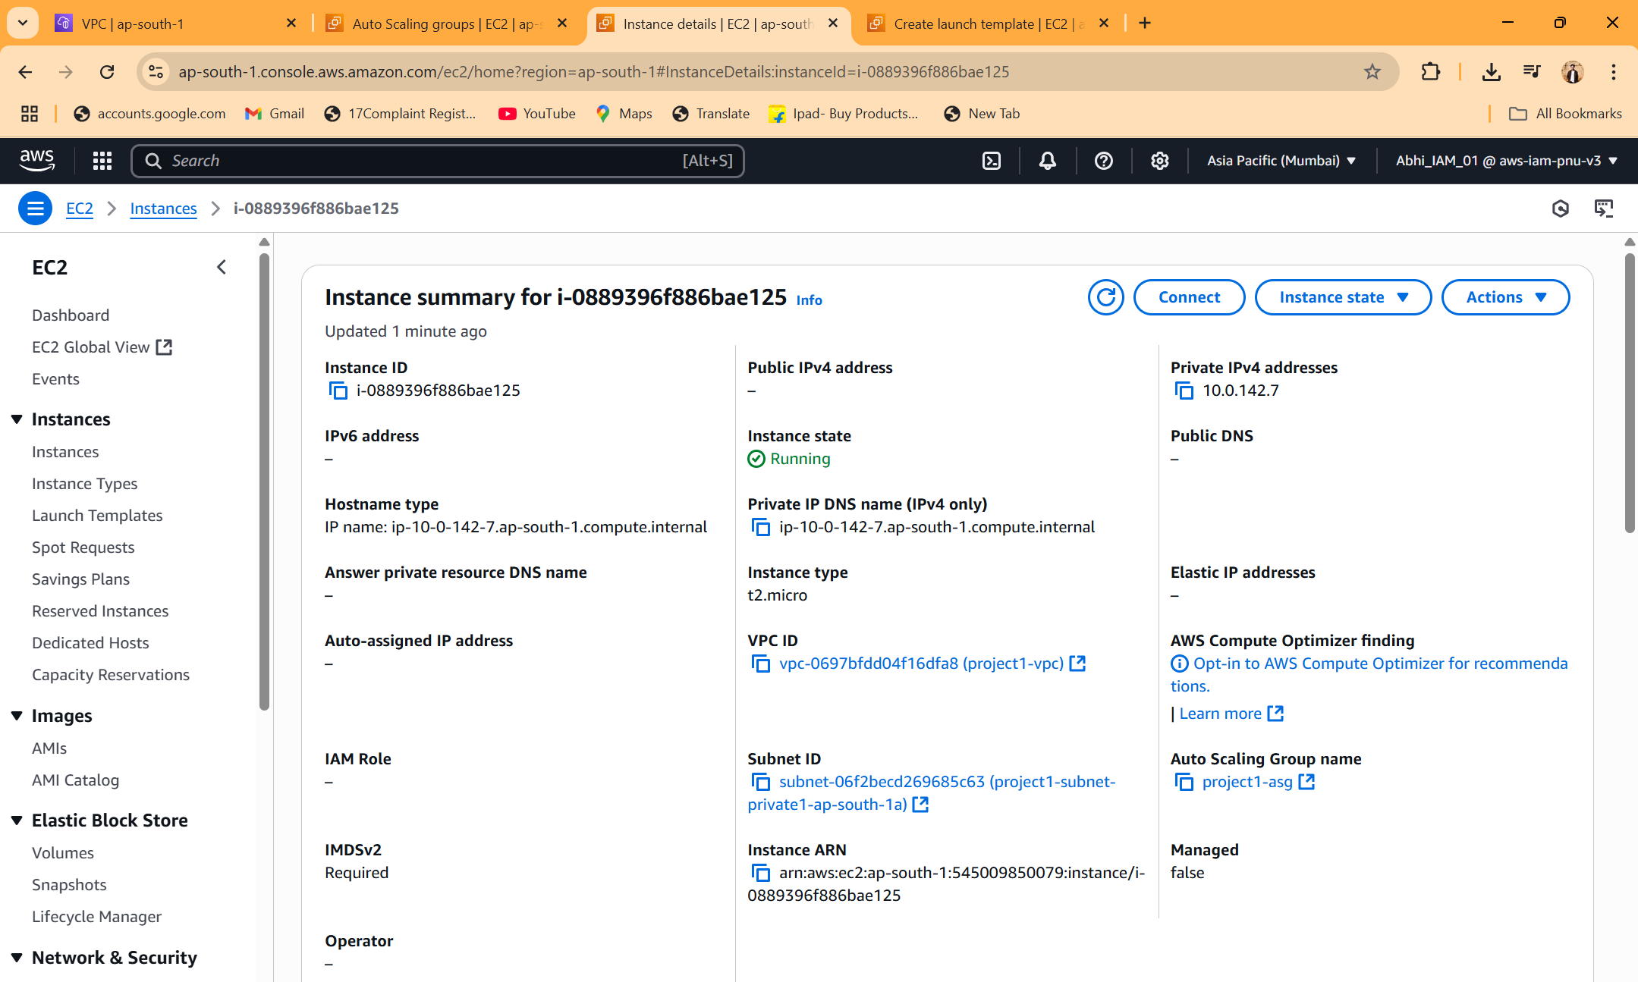  
  
  
  
STEP 4 – launch Bastian host   
  
note -  
 make sure this instance have ssh permission and in same vpc   
  
steps and configuration for Bastian instance  
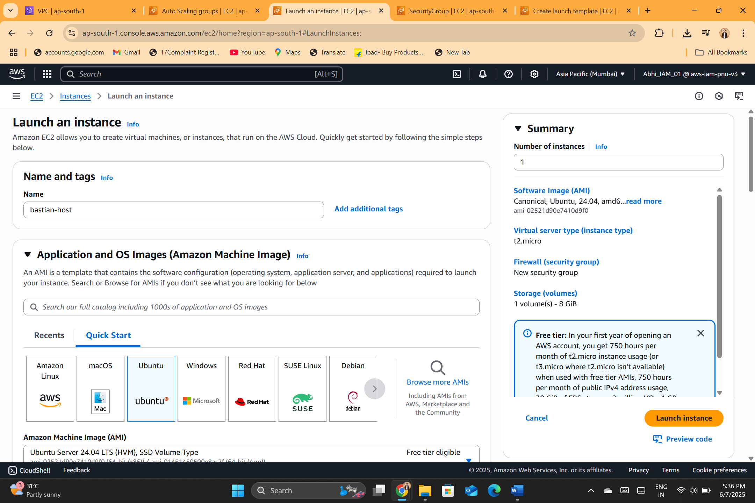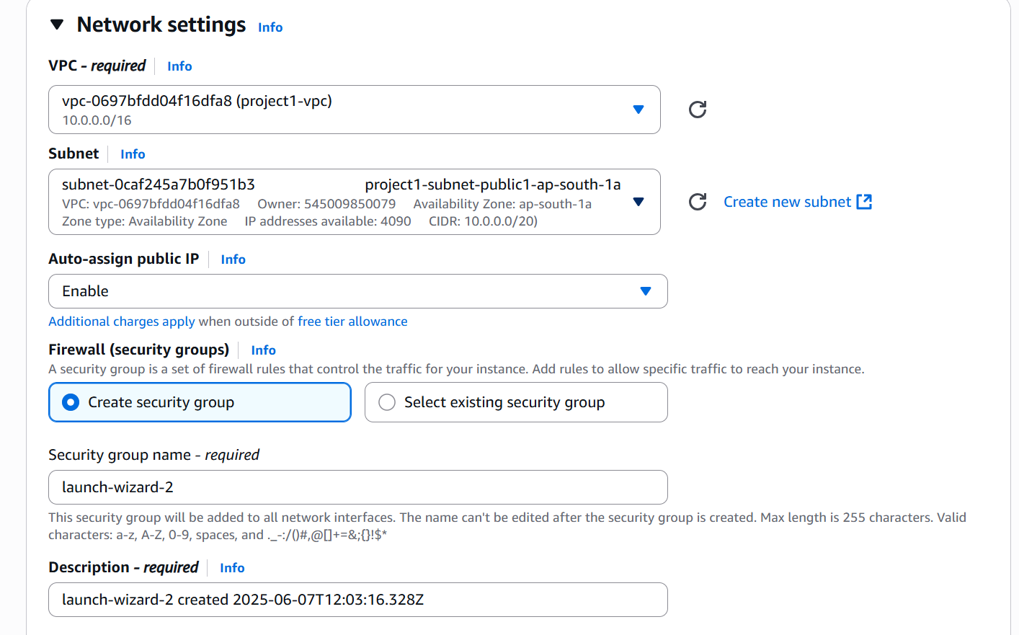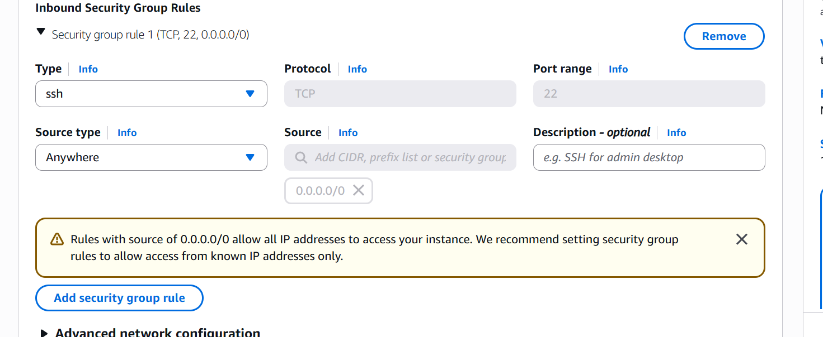**

**Copy the .pem file to the Bastian host   
  
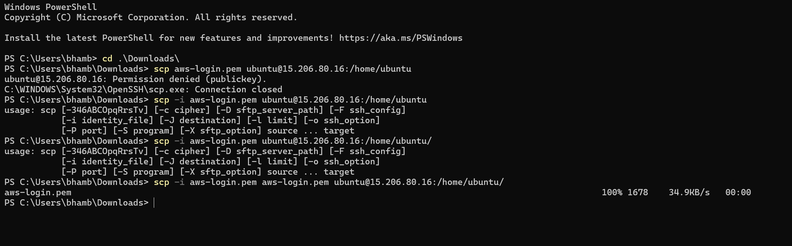**

Command - scp -i aws-login.pem aws-login.pem ubuntu@15.206.80.16:/home/ubuntu/ 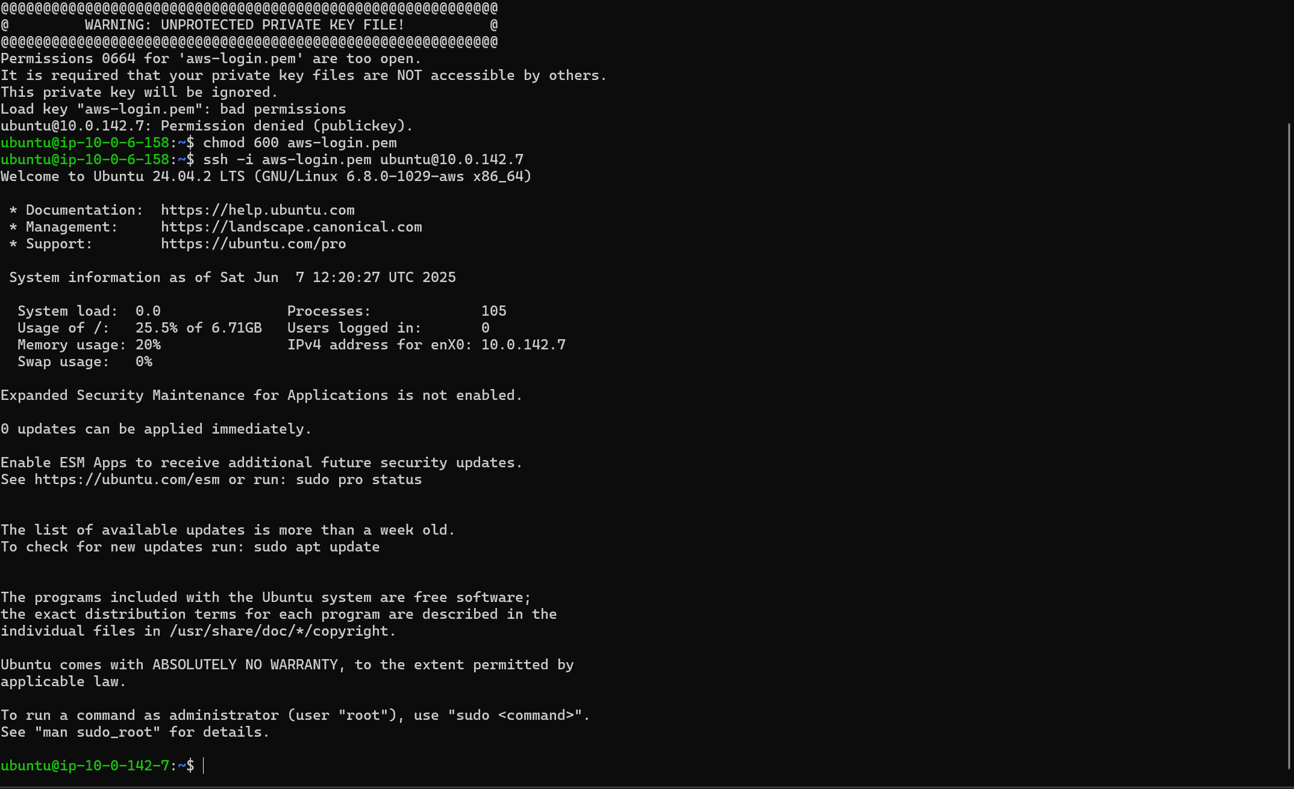starting the python server

command- python3 -m http.server 8000  
 **STEP 5 -LAUNCH APPLICATION LOAD BALANCER  
  
before launching ALB must create one target group   
  
after that launch ALB**

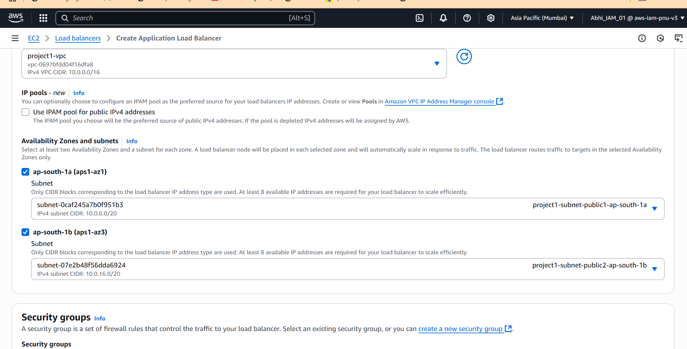

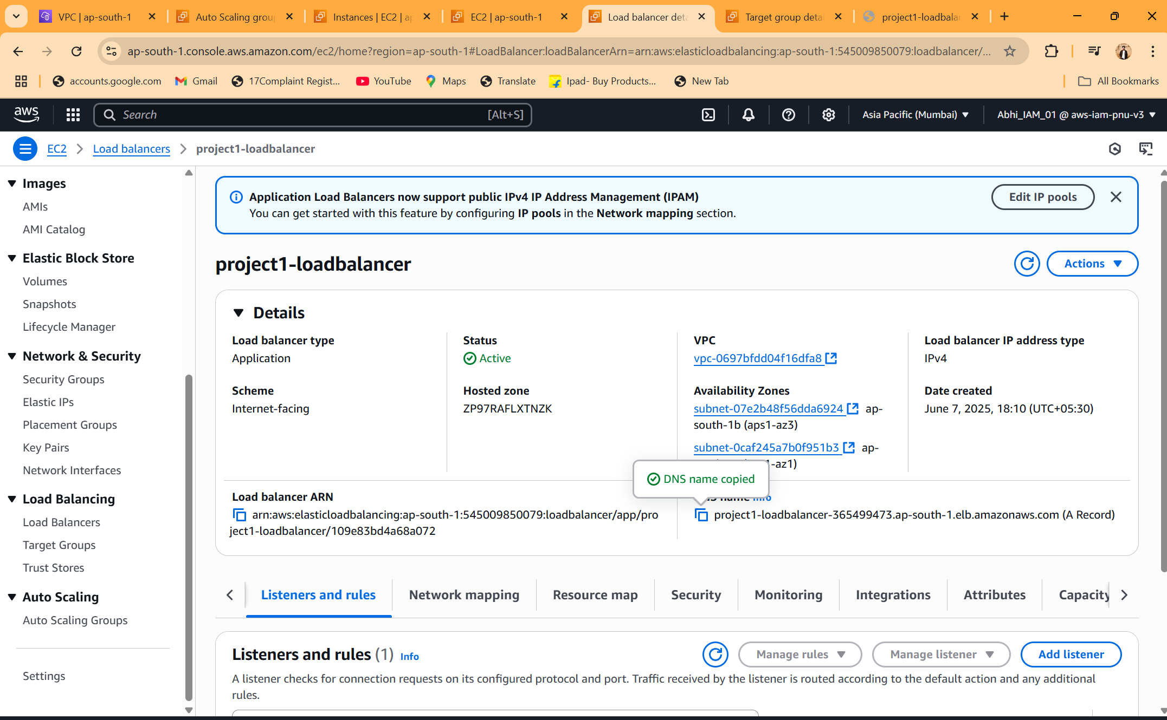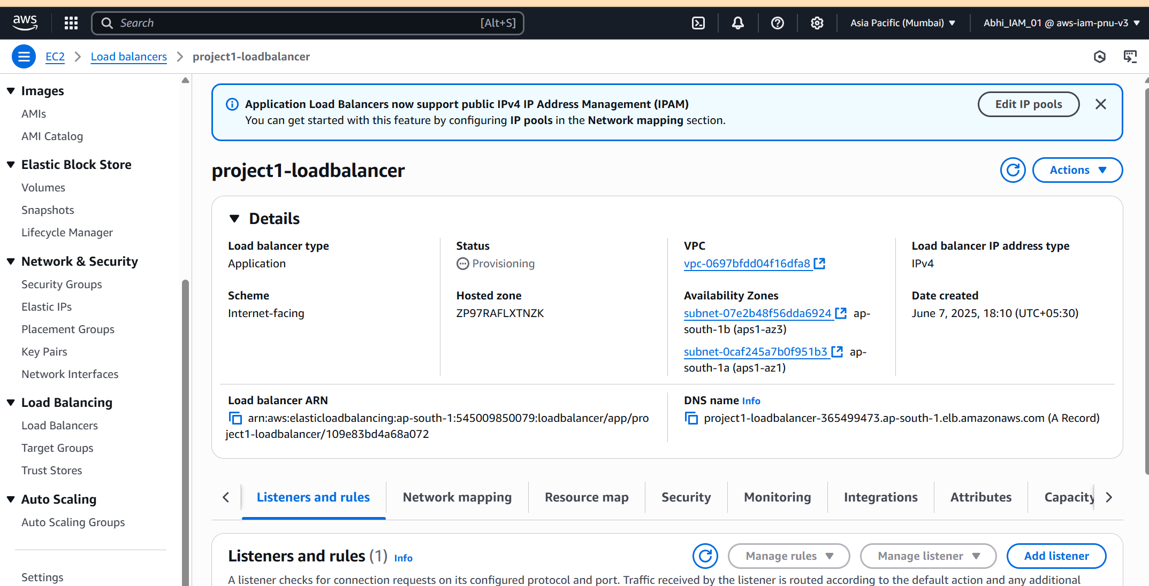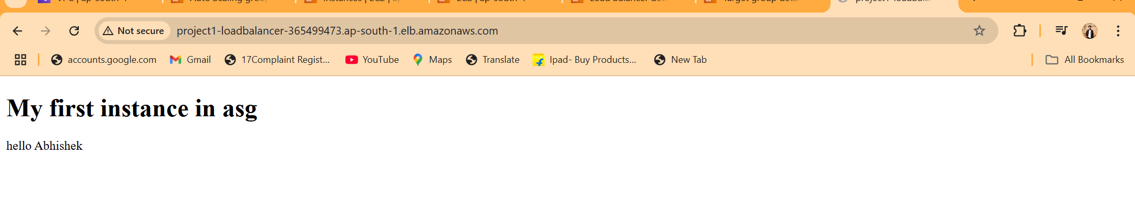

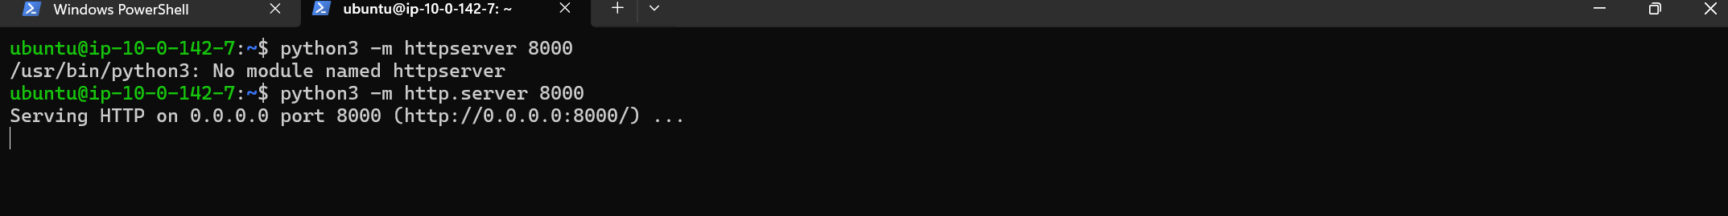to check whether our application is working fine just copy the DNS name of your ALB and paste in any browser